JOBSHEET 7
LOOP 1
- Learning Outcome
After finishing this topic, students must be able to:
- explain the format of loop programming part 1
- implement a loop part 1 flowchart using the Java programming language

- Labs Activity
  - Lab 1: Counting Multiples Using FOR Time: 60 minutes
In this experiment, the code is created to display multiples of a specific number within the range of 1 to 50 using a FOR loop, and to calculate the total of these numbers.
    - Open text editor. Create a new Java File named ForMultiplesNoAbsen.java
    - Create the basic structure of Java program containing class declaration and main()
method
    - Add the Scanner library.
    - Create or declare variable named input from Scanner library.
    - Create int variables named multiple, sum, and counter. Initialize variable sum and
counter with 0.
    - Add the following code to get the user input!
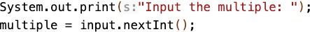
    - Create the FOR loop with IF condition to evaluate the multiples number
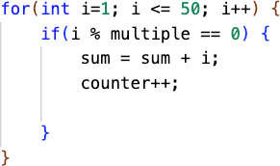

    - Display the sum and counter of multiples number in range from 1 to 50.

    - Run the program and analyze the result. Your result must be like this:
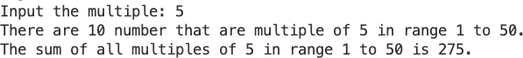

Questions
- There are 3 main comp onents in FOR loop. Based on experiment 1 above, identify and explain these 3 components!
# Component 1: Initialization
- int i = 1;
- This part runs once before the loop starts.
- It initializes the loop control variable (i) with a starting value — in this case, 1.
# Component 2: Condition
- i <= 50;
- This is the test expression that decides whether the loop should continue running.
- As long as the condition is true, the loop executes.
- When i becomes greater than 50, the loop stops.
# Component 3: Update/Increment
- i++
- This is executed after each iteration of the loop.
- It increases the value of i by 1.
- This ensures progress toward ending the loop.
- Explain how the following code works!

# i % multiple == 0 checks whether i is a multiple of the given number.
-% is the modulus operator, which returns the remainder after division.
-If the remainder is 0, then i is evenly divisible by multiple.
# sum /= sum + i;
-Adds the current multiple (i) to the total sum.
# counter++;
-Increases the count of how many multiples have been found by 1.

- Modify the existing code by adding a new variable to calculate the average of all the specified multiples!
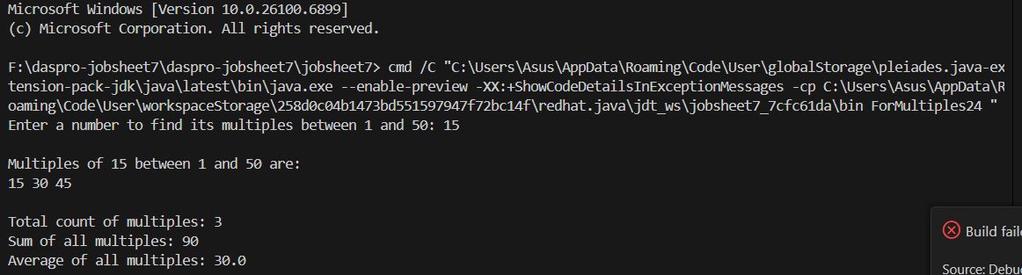
- Create a new Java program file named WhileMultiplesNoAbsen.java.
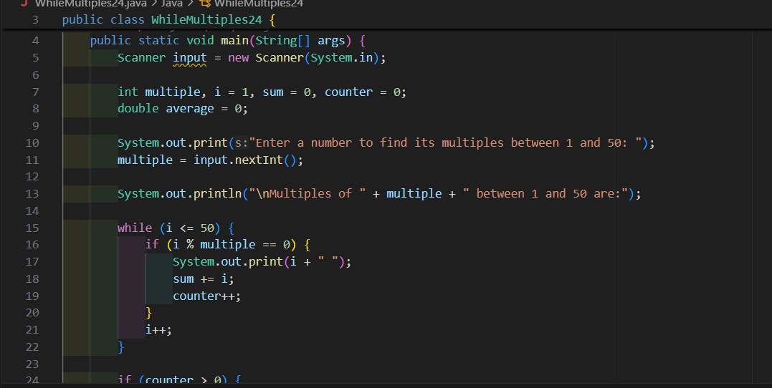

  - Lab 2: Show Multiplication of 2
Times: 40 minutes
We want to create a program which take any number more than 2 and print the multiplication of 2 within given input.
    - Open the text editor and create a new Java file named DisplayTwoNoAbsen.java
    - Create the basic structure of Java program containing class declaration and main() method
    - Add the Scanner library.
    - Create or declare variable named input from Scanner library.

    - Declare int variable named numInput.
    - Add the following code to input from user.
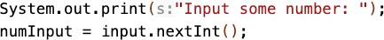
    - Add this following FOR loop.
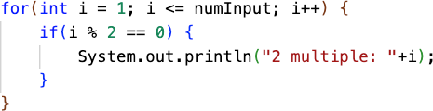
    - Compile and run the program.
    - Expected result:
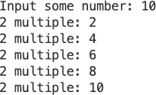
Questions
- Do modification to make the program produce similar result but WITHOUT IF statement. Please insert a screenshot of your code to the report.
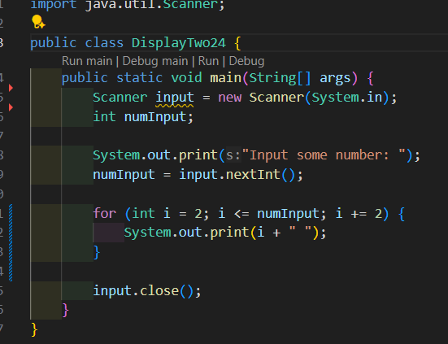
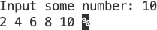
- Do modification to make the program print like this following result. Please insert a screenshot of your code to the report.
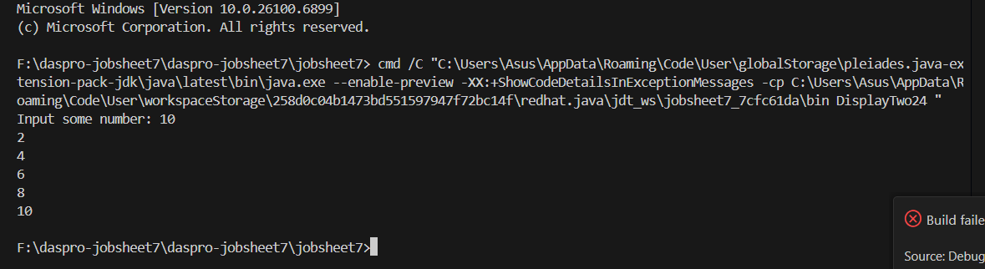

  - Lab 3: The Triangle
Duration: 30 minutes
In this lab, you will create a rectangle pattern using single loop.
    - Open the text editor and create a new Java file called TheTriangleNoAbsen.java.
    - Create the basic structure of Java program containing class declaration and main method.
    - Add the Scanner library.

    - Create a variable input from Scanner library.
    - Create int variable called numInput.
    - Create int variable called i and give 0 as initial value.
    - Create String variable called s and give empty string as initial value.
    - Add this following code to take the input from user.
    - Add this following loop, to print the rectangle pattern.
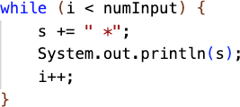
    - The expected result:
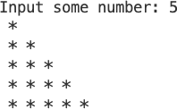

Question
- Do a modification on the program therefore your program utilize FOR statement rather than WHILE statement.
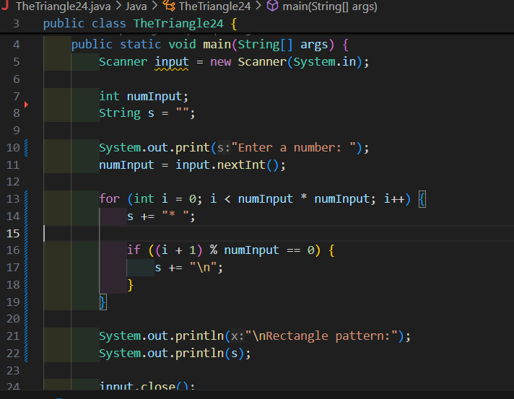
- Explain the meaning of s += “ *” and why is it possible?
Because in Java:
- s is a String.
-The + operator is overloaded for strings — it’s used for concatenation (joining).
-Every time you write s + "* ", Java creates a new String that combines both.

  - Lab 4: Calculating Leave Entitlement Using DO-WHILE

Times: 50 minutes
In this experiment, a program code is created using DO-WHILE to calculate the leave entitlement of an employee. Employees are entitled to 5 days of leave. Leave days will be deducted each time they are used. When there are only 2 days of leave remaining, the employee receives a warning to stop using their leave
    - Open the text editor and create a new Java file named

DoWhileLeaveEntitlementNoAbsen.java

    - Create the basic structure of Java program containing class declaration and main() method
    - Add the Scanner library.
    - Create or declare variable named input from Scanner library.
    - Create variables leaveEntitlement and numLeave with int datatype.
    - Create variable confirmation with String datatype.
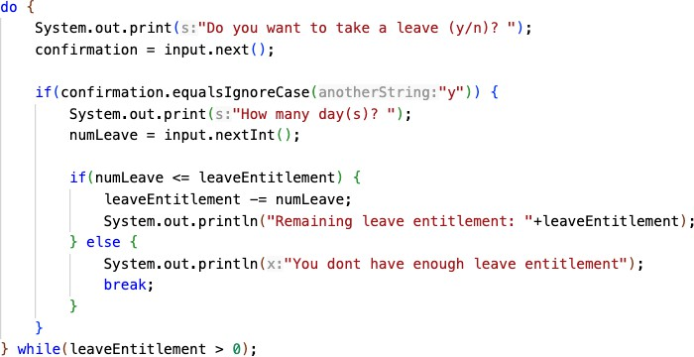
    - Create a DO-WHILE loop structure to get the user input from the keyboard and calculate leave entitlement
    - Run the program and analyze the result. It must be the same with the following output.
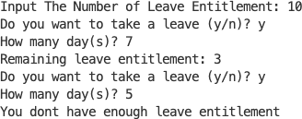

Questions
- What is the use of the BREAK within the loop syntax?
The break statement is used to immediately stop or exit a loop (like for, while, or do-while) before its condition becomes false.
- Modify the program so that if the number of leave days requested is greater than the remaining entitlement, the program does not stop, allowing the user to enter the number of days according to the entitlement.
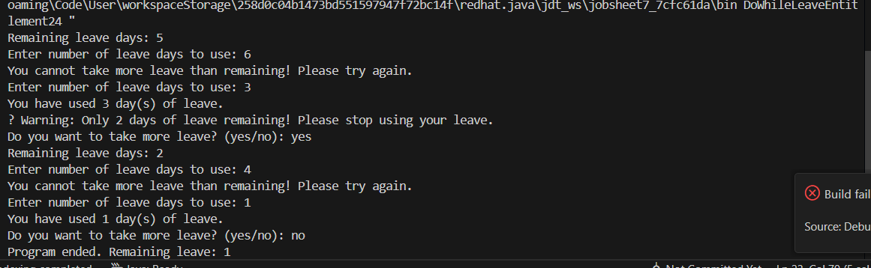
- Commit and push the program code to GitHub.
- When typing "t" as the confirmation input, what happens? Why?
Because “t” does not satisfy the condition “yes” , so the do-while loop doesn’t repeat.
- Modify the program code so that when the user enters "t" as the confirmation input, the program will stop.
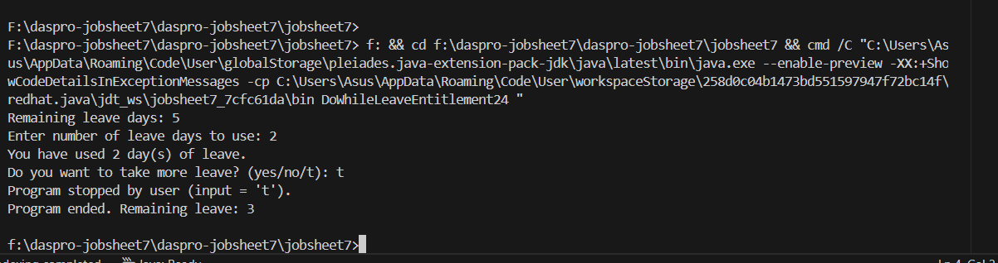
Assignment (Open Challenge)
- Do a modification on the program from the lab 3, so you get this following result,

